Министерство образования и молодежной политики Свердловской области

ГАПОУ СО «Екатеринбургский колледж транспортного строительства»

Отчет по ТРПО. Лабораторная работа №3  
**«Основные элементы управления WPF».**

Выполнил: Гордейчик С.А.

Группа: ПР-31

Преподаватель: Бушуева Е.В.

2024

Разметка (задание 1):

<Window x:Class="Task1.MainWindow"

xmlns="http://schemas.microsoft.com/winfx/2006/xaml/presentation"

xmlns:x="http://schemas.microsoft.com/winfx/2006/xaml"

xmlns:d="http://schemas.microsoft.com/expression/blend/2008"

xmlns:mc="http://schemas.openxmlformats.org/markup-compatibility/2006"

xmlns:local="clr-namespace:Task1"

mc:Ignorable="d"

WindowStartupLocation="CenterScreen"

Title="Task - 1" Height="450" Width="800">

<Grid>

<Grid.RowDefinitions>

<RowDefinition Height="Auto"/>

<RowDefinition Height="*"/>

<RowDefinition Height="25"/>

<RowDefinition Height="Auto"/>

</Grid.RowDefinitions>

<Menu Grid.Row="0">

<MenuItem Header="Файл">

<MenuItem Header="Выход" Click="MenuItemExit_Click"/>

</MenuItem>

<MenuItem Header="Вид">

<MenuItem Header="Красный" Click="MenuItemBackground_Click" MouseEnter="MenuItem_MouseEnter" MouseLeave="MenuItem_MouseLeave"/>

<MenuItem Header="Зеленый" Click="MenuItemBackground_Click" MouseEnter="MenuItem_MouseEnter" MouseLeave="MenuItem_MouseLeave"/>

<MenuItem Header="Синий" Click="MenuItemBackground_Click" MouseEnter="MenuItem_MouseEnter" MouseLeave="MenuItem_MouseLeave"/>

</MenuItem>

<MenuItem Header="Помощь">

<MenuItem Header="Инфо о разработчике" Click="MenuItemDeveloperInfo_Click" MouseEnter="MenuItem_MouseEnter" MouseLeave="MenuItem_MouseLeave"/>

</MenuItem>

</Menu>

<ToolBar Grid.Row="2">

<Button Content="Красный" Click="ButtonBackground_Click" MouseEnter="Button_MouseEnter" MouseLeave="Button_MouseLeave"/>

<Button Content="Зеленый" Click="ButtonBackground_Click" MouseEnter="Button_MouseEnter" MouseLeave="Button_MouseLeave"/>

<Button Content="Синий" Click="ButtonBackground_Click" MouseEnter="Button_MouseEnter" MouseLeave="Button_MouseLeave"/>

<Button Content="Инфо о разработчике" Click="MenuItemDeveloperInfo_Click" MouseEnter="Button_MouseEnter" MouseLeave="Button_MouseLeave"/>

<Button Content="Выход" Click="MenuItemExit_Click"/>

</ToolBar>

<StatusBar Grid.Row="3">

<StatusBarItem>

<TextBlock x:Name="statusLabel" Text="Готово"/>

</StatusBarItem>

</StatusBar>

</Grid>

</Window>

Код (задание 1):

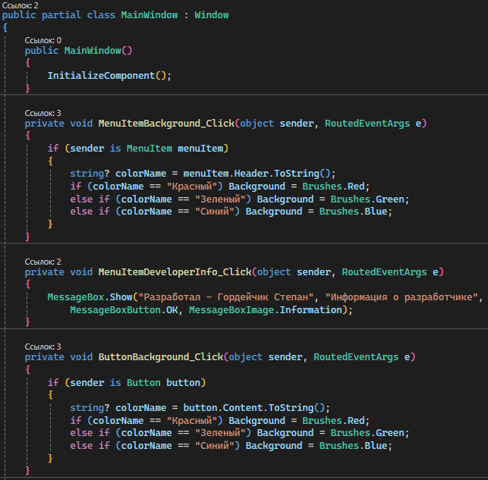

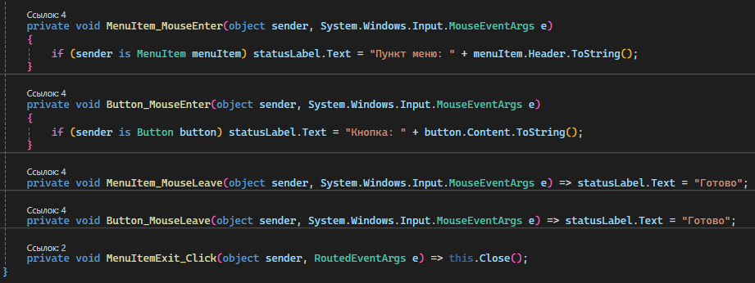

Снимок экрана (задание 1):

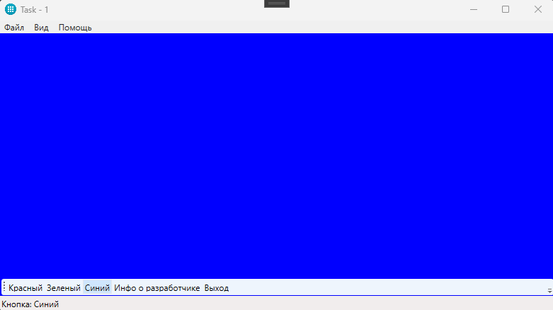

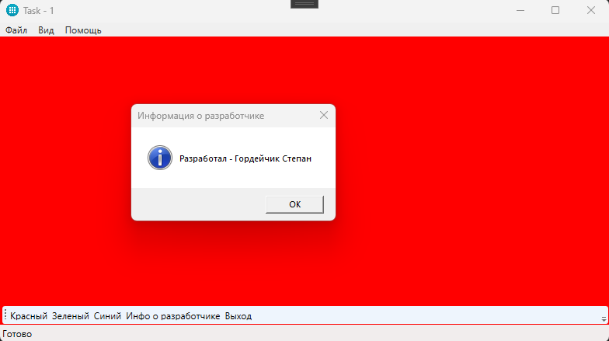

Разметка (задание 2):

<Window x:Class="Task2.MainWindow"

xmlns="http://schemas.microsoft.com/winfx/2006/xaml/presentation"

xmlns:x="http://schemas.microsoft.com/winfx/2006/xaml"

xmlns:d="http://schemas.microsoft.com/expression/blend/2008"

xmlns:mc="http://schemas.openxmlformats.org/markup-compatibility/2006"

xmlns:local="clr-namespace:Task2"

mc:Ignorable="d"

WindowStartupLocation="CenterScreen"

Title="Task - 2" Height="450" Width="800">

<Window.Resources>

<Style x:Key="ComboBoxStyle" TargetType="ComboBox">

<Setter Property="Margin" Value="5"/>

</Style>

<x:Array x:Key="MyEditingModes" Type="{x:Type InkCanvasEditingMode}">

<x:Static Member="InkCanvasEditingMode.Ink"/>

<x:Static Member="InkCanvasEditingMode.Select"/>

<x:Static Member="InkCanvasEditingMode.EraseByPoint"/>

<x:Static Member="InkCanvasEditingMode.EraseByStroke"/>

</x:Array>

<x:Array x:Key="MyDrawingAttributes" Type="{x:Type local:MyDrawingAttribute}">

<local:MyDrawingAttribute Color="Black" Width="5" Height="5" Name="Черный"/>

<local:MyDrawingAttribute Color="Red" Width="5" Height="5" Name="Красный"/>

<local:MyDrawingAttribute Color="Green" Width="5" Height="5" Name="Зеленый"/>

<local:MyDrawingAttribute Color="Blue" Width="5" Height="5" Name="Синий"/>

</x:Array>

</Window.Resources>

<Grid>

<Grid.RowDefinitions>

<RowDefinition Height="Auto"/>

<RowDefinition Height="Auto"/>

<RowDefinition Height="*"/>

</Grid.RowDefinitions>

<StackPanel Grid.Row="0" Orientation="Horizontal">

<Label Content="Цвет кисти:" VerticalAlignment="Center"/>

<ComboBox x:Name="colorComboBox" SelectedIndex="0" ItemsSource="{StaticResource MyDrawingAttributes}" SelectedValue="{Binding Path=DefaultDrawingAttributes, ElementName=inkCanvas}" DisplayMemberPath="Name" Style="{StaticResource ComboBoxStyle}"/>

<Label Content="Размер кисти:" VerticalAlignment="Center" Margin="10,0,0,0"/>

<Slider x:Name="sizeSlider" Width="100" Minimum="1" Maximum="20" Value="5" Margin="5" ValueChanged="sizeSlider_ValueChanged"/>

</StackPanel>

<StackPanel Grid.Row="1" Orientation="Horizontal">

<Label Content="Режим работы:" VerticalAlignment="Center"/>

<ComboBox x:Name="modeComboBox" ItemsSource="{StaticResource MyEditingModes}" SelectedItem="{Binding Path=EditingMode, ElementName=inkCanvas}" Style="{StaticResource ComboBoxStyle}">

<ComboBox.ItemTemplate>

<DataTemplate>

<TextBlock Text="{Binding}"/>

</DataTemplate>

</ComboBox.ItemTemplate>

</ComboBox>

</StackPanel>

<InkCanvas x:Name="inkCanvas" Grid.Row="2" Background="White" />

</Grid>

</Window>

Код (задание 2):

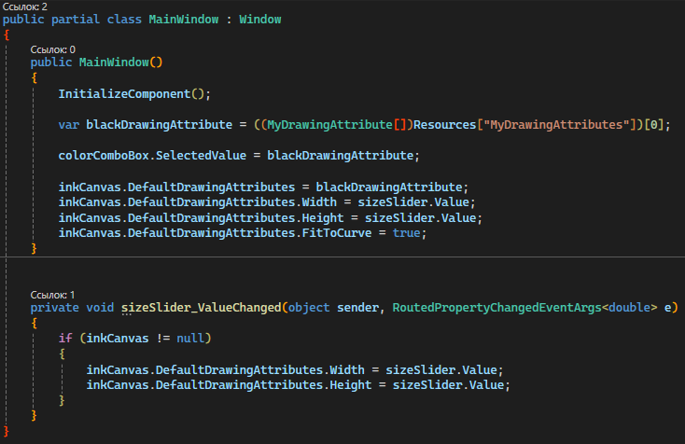

Снимок экрана (задание 2):

